Life’s too short for boring nails….

About me
Hi there, my name is Kim and I am a nail technician with 12 years’ experience in gel, acrylics and gel polish design. I also have a passion for vintage fashion and love being different. I have had pink, purple, black and grey hair (some au natural) and I’m not afraid of scissors or shavers! I have recently been experimenting with bringing vintage accents and styles into nail designs which have become really popular with not only myself but my clients as well. I am hoping that you will enjoy what I love to do and experiment for yourself. Life is too short for boring nails! Glam on….

Most women love a bit of fashion and especially like to feel glamorous. From the iconic winged eye liner flick to the perfectly outlined cupids bow and big pinned hair, manicures are really the icing on the cake! My mother always told me to look at a man’s footwear to tell you what type of a person he is, and for a woman it’s their hands. After all, a well-manicured set of pinkies are part of a woman’s everyday conversation either at on the school run or at work. There’s nothing better than someone saying “Wow I love your nails, where did you get them done?” and replying that it was me who created them. It really is a great feeling knowing that the tears, tantrums and all the training have started to pay off, especially as I was never arty at school and the most I ever mastered was an awesome stick man and lady with a triangle skirt.

It has never been so easy to access products and information in the beauty industry since the beginning of the internet. You can not only buy and sell such things but there is an endless supply of learning opportunities on your doorstep, well smart phone – even lessons via Skype are proving to be popular! Don’t get me wrong, as a nail technician I have experienced a variety of learning opportunities and the best by far for me was a one to one. However, I get a lot of inspiration and education from Youtube. Some of the greatest people in the industry provide free videos to watch anytime. But the nail industry is not something new, it can be traced back thousands of years ago where the Chinese would paint their nails with various concoctions and sit several hours to get their desired effect. At one point, having your nails painted meant that work was beneath you and only the privileged were eligible to have it done. The painting of nails in different eras has meant different things at different times, even down to the shade of colour that was used. Try Googling how many shades red there are, there are hundreds!
Let’s jump forward, much more forward in time to the 1920’s. This was when car paint became the craze for painting nails and the beauty industry boomed, but it was 1930’s where Revlon launched a revolutionary product using pigments instead of dyes which transformed the industry on its head and became available for home users to purchase.

It wasn’t really until the 1940’s where we saw the likes of Hollywood actresses wear full red nail claws or red nails with crescents. Nowadays nail technicians may sometimes refer to the style as negative space. Either way, it has come full circle and is just as popular now as it was then.
You might be asking how does the floral design feature with the 1940’ and 1950’s era in nail patterns? As most of you professional vintage goers know, floral prints and polka dots were the height of fashion for this period and they are just as popular today as they were back then! This trend can be found in most high street stores on clothing and accessories alike. This time the trend seems to have stuck well and truly but I’m sure none of us are complaining in the slightest! I don’t think I could ever get bored of such a classic and elegant look. With the likes of fashion designers such as Cath Kidston (which I absolutely adore favouring this style) with accessories and now clothes, have massively grown in popularity and more and more vintage fairs popping up on the social calendar all over the country, cute floral designs are being grabbed where you can get them.
It wasn’t until the after the millennium when 3D nail art, crystals and gel polish etc. rose in popularity and designs were endless. It’s probably harder now to choose a design than it was before this trend. Put it this way, nowadays choosing a nail design is like going to a restaurant with a menu with over a hundred meals to choose from, but back then it was like going to a restaurant with only two starters, two main courses and two desserts to choose from. For me on an uncreative day, it is an absolutely nightmare! Designs and colours are endless!

Something in you changes when you’ve had a manicure. It changes the way you feel, the way you look and the way your hands dance. There is an air of elegance about well looked after hands and flowers are the ultimate symbol of elegance and natural beauty itself. What more is there than to bring style from such a classic era to the skills of the 21st century. Elegant nails with a floral design and subtle colours to match…

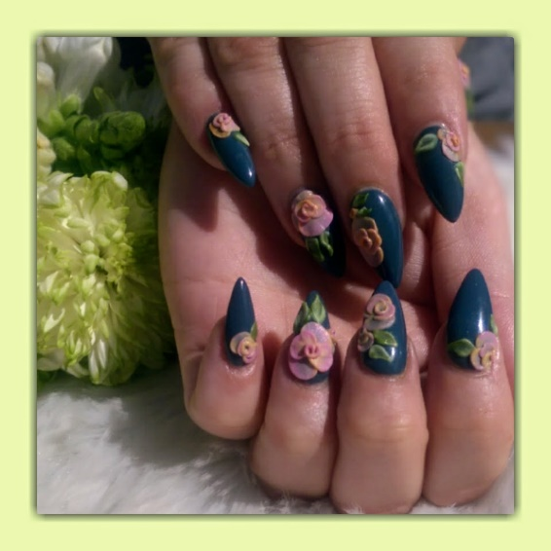

I’ve absolutely loved doing these nails and this article for you. I hope you are able to have a go yourself at home. Here are some suggestions how you can bring this vintage inspired look at home.

Preparation:
Optional if you have time!
Prepare hands and nails by using a body scrub over them to get any debris and dirt off that would diminish the desired effect, plus it feels nice! Push back cuticle with a wooden orange cuticle stick.
Why: Your nail plates appear longer and the polish will adhere better around the cuticle area.
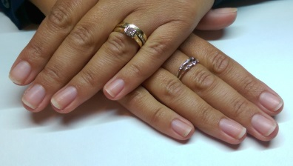

Step 1.
Apply your chosen base coat, the aim of any polish application is in three strokes. One down the centre, to the left and then the right. This is to ensure the coat is even. Try not to keep brushing on top of it as this will create a dragging effect and make the surface uneven as it begins to dry.
Why?
Base coats will do two things. It is designed to stop your nail getting stained from highly pigmented colours and will also help any ridges in the nail smooth out for even an coverage. It is also ensures your chosen colour will last longer. It provides a prefect surface to stick to and help stop those pesky chips!

Step 2.
Again with three stokes, apply your chosen colour. Now most polishes only require two coats, some can be highly pigmented and only need the one which is music to everyone’s ears. Personally the maximum I would do is three as drying time and the risk of ruining application is higher. Leave enough time for each layer to dry before applying the next!
Hint:
Sometimes the first layer of nail polish can look slightly patchy until all of the coats are applied, don’t be tempted to apply to thickly. It will take much longer to dry and look unprofessional. Thin coats dry faster and have a smoother appearance. Make sure the edges of your nail are ‘capped’ in polish so they don’t chip.
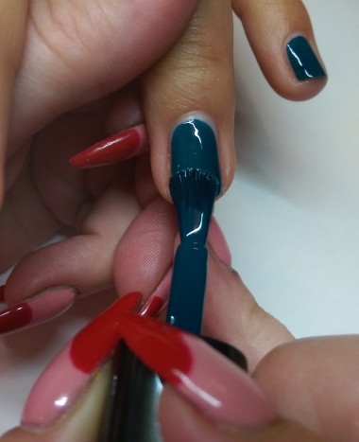

Step 3.
Using tweezers or your own nails, carefully tease the sticker off the packaging and place on nail. Don’t get your fingers over the polish as you will leave fingerprint indentations on your polish! Make sure that all of the edges are stuck down.
Hint:
You don’t have to use one sticker, you can layer them to create your own bouquet!

Step 4.
Apply top coat. Similarly when applying your base and colour, use three thin strokes and cap the edges with a good quality top coat then repeat. This ensures all edges of the stickers are covered so you won’t be tempted to pick at them and ruin your hard work.
Hint: Once completely dry, apply cuticle oil then raise your arms out in front of you and admire your art. Well done!

Here is the finished look!

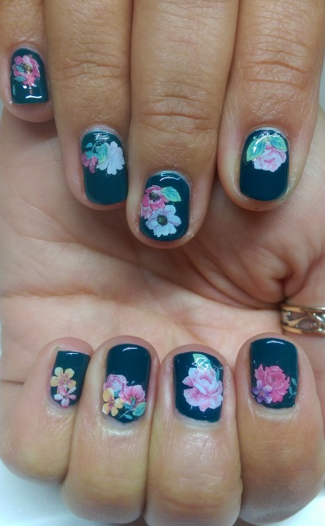
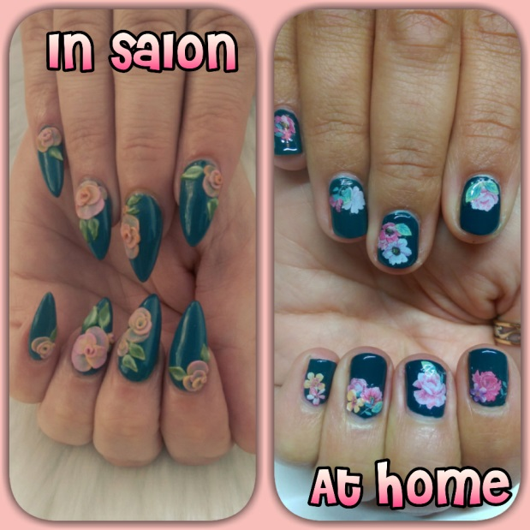

Love and best wishes
Kim xxx
Glam on….

Product information and availability:
Nails at home:

Product | Range | Distributor | Contact details
Base and top coat | Caption polish range (also available for professional use) | Young Nails | www.youngnails.co.uk  Call to find salon stockists.  01253 699999
Nail polish | No 7 | Boots stores - Nation wide | www.boots.com
Nail stickers | Nail decals – DECO IT HIPPIE SUMMER | Iz Beauty of London by Izabelle Hammon | www.izabellehammon.com
NAIL DECALS | FEMME FATALE | FEMME FATALE NAILS | www.femmefatale.co.uk

Professionals only:
Product | Range | Distributor | Contact details
Vanilla shine acrylic and original monomer | Strength Powder | CJP nail systems | www.cjpnailsystems.com
ManiQ gel polish blue 103;  ManiQ topcoat  Green acrylic;  Orange darling;  Tangerine;  Blushing girl;  Guillible green; | ManiQ gel polish  ManiQ gel polish  Pop brights collection  Pastel collection  Pop brights collection  Pastel collection  Pastel collection | Young Nails | www.youngnails.co.uk  01253 699999

