Femme Fatale Cupcakes design step by step!

I love the summer, don’t get me wrong I love the crisp winter snow and how pretty it is but I think everyone likes a bit of sunshine on their face especially as the recent summers aren’t anything to brag about! I love the light evenings and bright cheery colours, summer fates and picnics all around. I love the bunting and cucumber sandwiches and the BBQ smell at the end of every street symbolising spending time with those you love. Iconic bunting and cupcakes have made a fabulous come back and look so pretty they are even now seen at Christmas time, so bunting can bought with pretty much everything on it. Cupcakes are replacing birthday cakes and fancy cupcakes stands are placed at the centre of parties. Inevitably I decided to design my display tips with this very theme in mind!

Step 1.
Apply your chosen base coat, the aim of any polish application is in three strokes. One down the centre, to the left and then the right. This is to ensure the coat is even. Try not to keep brushing on top of it as this will create a dragging effect and make the surface uneven as it begins to dry.
Why?
Base coats will do two things. It is designed to stop your nail getting stained from highly pigmented colours and will also help any ridges in the nail smooth out for even an coverage. It is also ensures your chosen colour will last longer. It provides a prefect surface to stick to and help stop those pesky chips!

Step 2.
Again with three stokes, apply your chosen colour. Now most polishes only require two coats, some can be highly pigmented and only need the one which is music to everyone’s ears. Personally the maximum I would do is three as drying time and the risk of ruining application is higher. Leave enough time for each layer to dry before applying the next!
Hint:
Sometimes the first layer of nail polish can look slightly patchy until all of the coats are applied, don’t be tempted to apply to thickly. It will take much longer to dry and look unprofessional. Thin coats dry faster and have a smoother appearance. Make sure the edges of your nail are ‘capped’ in polish so they don’t chip.

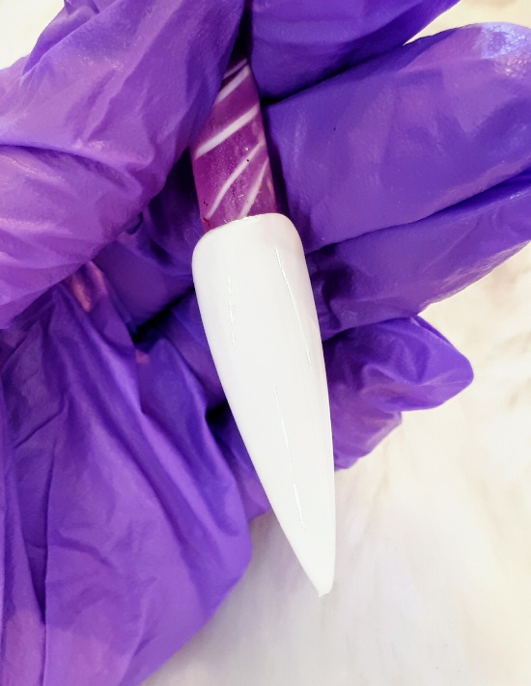

Step 3.
Cut out your decal as close as you can around the design and place it in a glass of room temperature water for about 15-20 seconds. However some require a few more seconds longer but don’t worry, it won’t damage the decal.
Hint:
You don’t have to use one decal, you can layer them to create your own art!
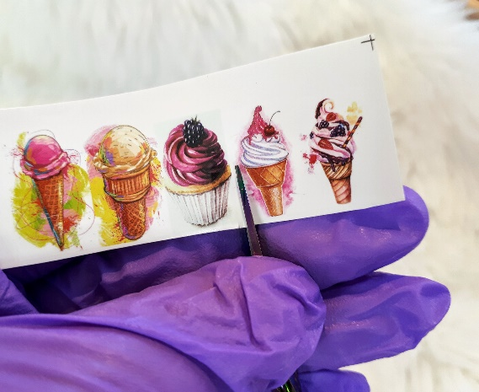

Step 4.
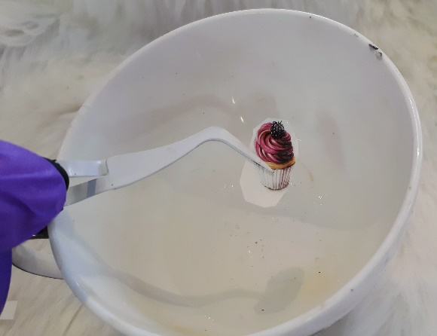

Using a pair of tweezers, take out the decal and slide it off from the backing paper.
Step 5.

Place on your dried nail of choice and lightly press with your fingers to make sure the edges are snug.

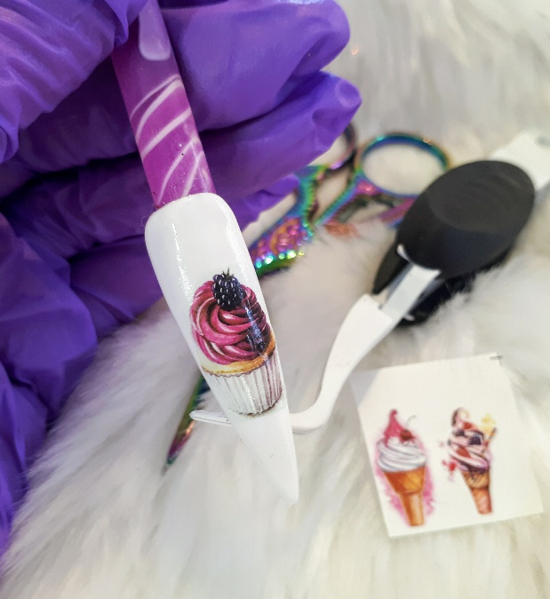

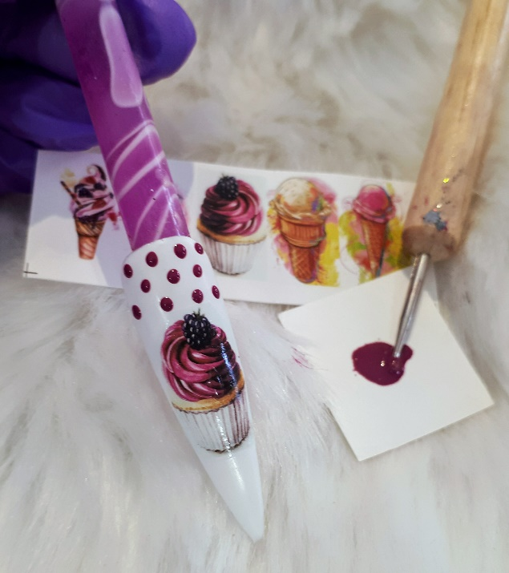
Step6.

Using a dotting tool or tooth pick what ever you have to hand, place dots around the decal and sure they are evenly spaced and leave to dry.

Step 7.
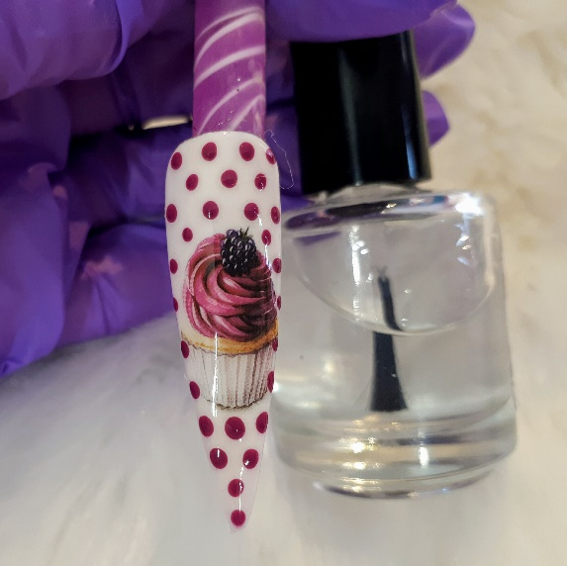

Use a good quality top coat and paint twice leaving each layer to dry before applying the next.

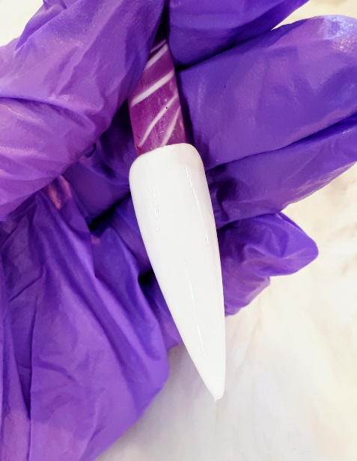
Step 8.

Again repeat steps 1 and 2 and wait until fully dry.

Step 9.

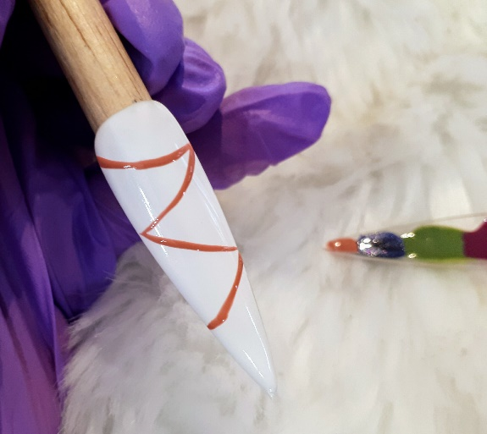
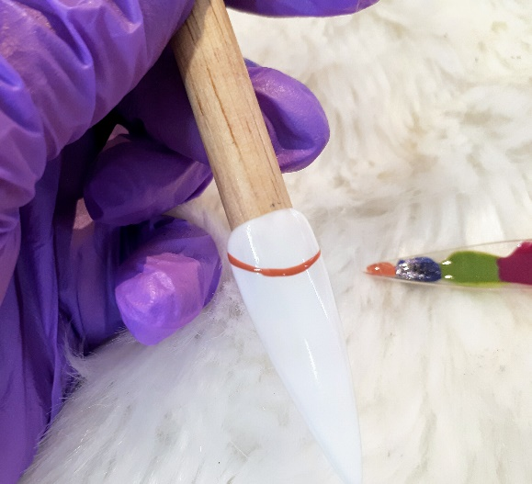

Decant some polish onto a non-absorbable surface. With a small thin striping brush draw a thin line in a zig zag pattern and leave to dry.

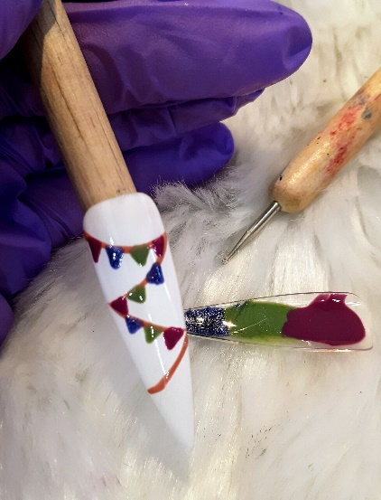
Step 10.
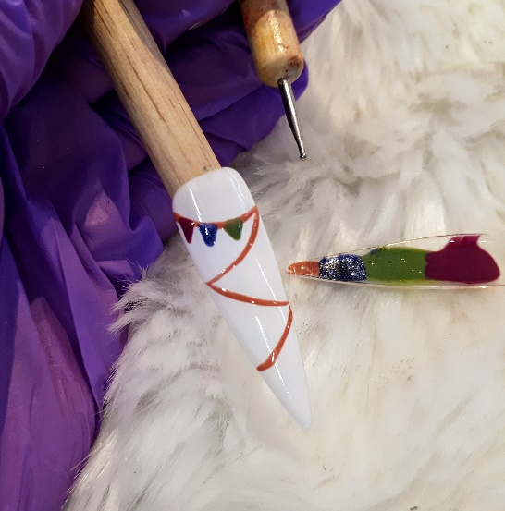

Again using a dotting tool or toothpick, draw triangle in different colours. You then must leave this to dry, so during this time you can work on the other patterns in a similar way.

Step 11.
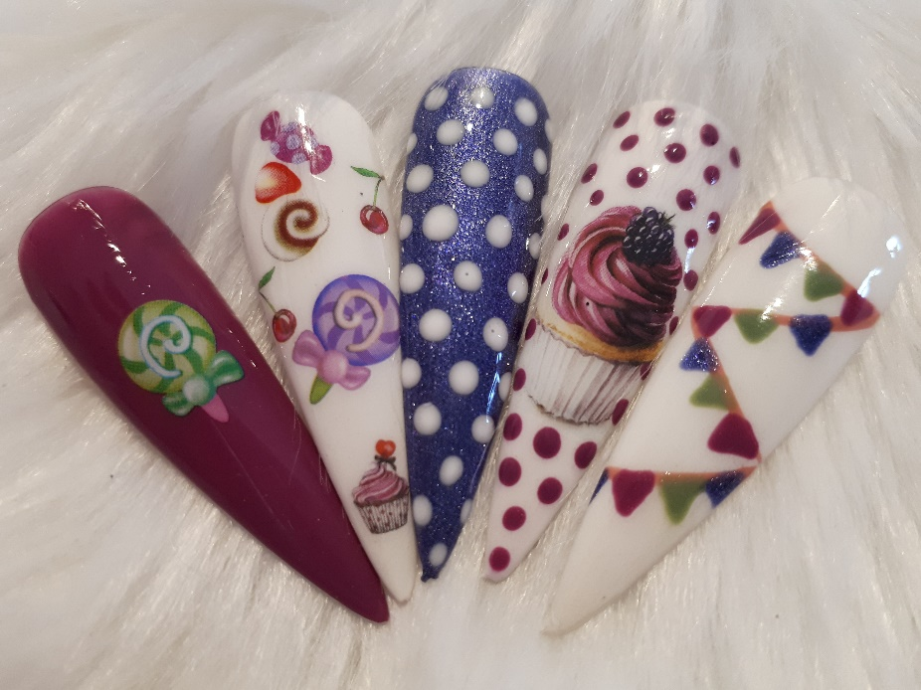

Apply top coat. Similarly when applying your base and colour, use three thin strokes and cap the edges with a good quality top coat then repeat. This ensures all edges of the stickers are covered so you won’t be tempted to pick at them and ruin your hard work.
Hint: Once completely dry, apply cuticle oil then raise your arms out in front of you and admire your art. Well done!
Take a look at my new online shop where you can get lots of vintage decals at www.femmefatalenails.co.uk

Love and best wishes
Kim xxxGlam on….

