Reverse application: Pink and whites using Team Gorgeous
- Pick up a bead of acrylic usually about half of the size of the nail bed but size is dependent on how long the extension will be. If designing the nail using the one bead method, place the first bead near the cuticle whilst tipping the nail down for gravity and the brush as a barrier to stop any flooding of the barrier. Using the tip of the brush, push the acrylic onto the nail bed following the client’s cuticle ensuring it remains flush to the natural nail.  - Move the body of the acrylic into a teardrop shape pulling to desired length of nail bed illusion. Don't worry too much as this can be filed in.  (The thickness should be the same all the way round the smile line).  - The cover pink should be the same thickness all the way around from sidewall to sidewall.  - If using 2/3 beads of cover pink, place a bead onto the middle of the nail to blend into the smile then one at the cuticle area (as above 1.)  - Then dry, file the smile line to ensure its sharp and crisp and keep the file completely vertical. If you file the smile at an angle your smile line will not be smiley :) Be careful when filing near the natural nail bed.  - Place a white acrylic bead on the tip and pat the bead along up to the cover pink and along to the side walls. If you need another bead of acrylic repeat on the opposite side of the smile line.  - Nothing is worse than when you begin filing and you haven't quite filled the acrylic to the body of the nail. Check to ensure that the corners of the smile lines are completely filled with acrylic, if you are unsure, place a very small white bead to both corners and wait until set.  - The reverse technique is a fantastic way to achieve an amazing smile. To ensure your white acrylic is completely flush when you file, place a small wetter bead on and around the smile line. The result can look messy but that's the beauty of reverse application.  - and 10. Once set, file around the perimeter of the nail for the desired shape and begin filing through the excess acrylic to reveal a perfect pink and white smile.  11. Remove dust and paint with desired topcoat. | 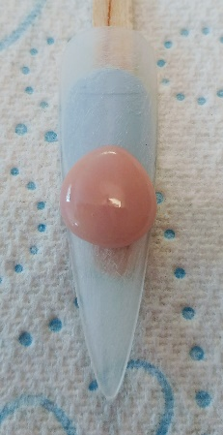  1.  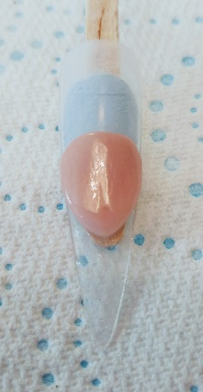  2.  3.  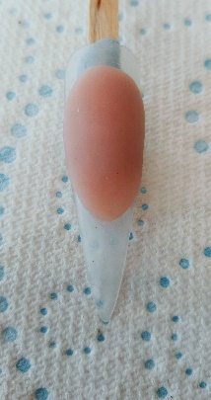  4  .  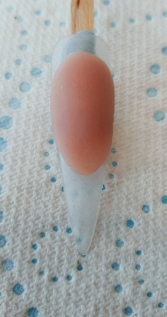  5.  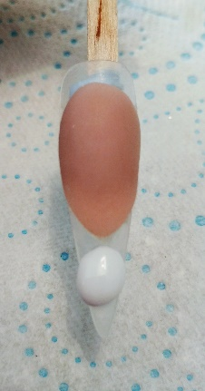  6.  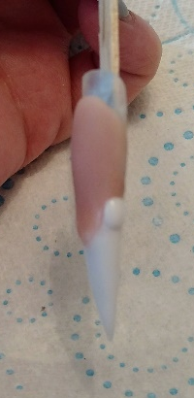  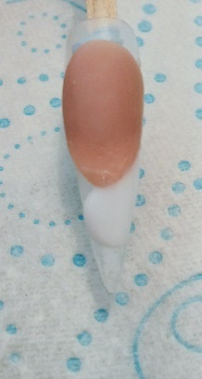  7.  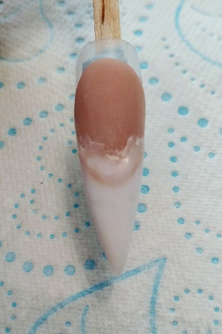  8.  9 and 10.  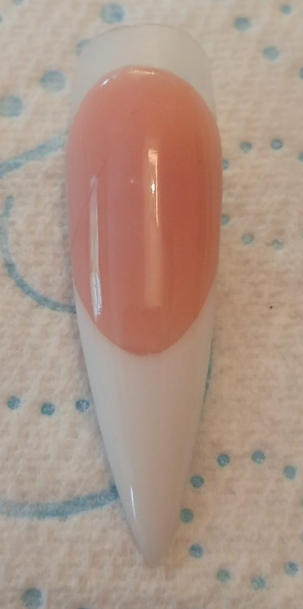  11.  Done!

